S A M P L E F L Y E R TO PROMOTE GOAL/PROGRAM

Your company logo here

To Wellness . . . and Beyond!

Your organization name is about people taking care of people. When the available people to take care of other people are diminished or depleted, things fall apart – for organizations, staff, and patients. Promoting wellness, and in particular mental wellbeing, is a top priority in 2022.

We encourage you to access the link below to listen to the one-hour webinar “To Wellness. . . and Beyond!” which highlights the evidence surrounding wellbeing and patient outcomes as well as focusing on how to move in a healthier direction personally, professionally, and organizationally.

To Wellness…and Beyond! – 1 Hour Webinar Recording  After viewing, please complete & submit the brief evaluation to receive a certificate of attendance or BRN credit. | 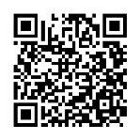

Bite Size Wellness Modules ~ 15 minutes each
View in any order. After listening to each module, please complete the brief evaluation.
Strategic Micro-Recovery | 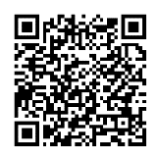 | The Power of the Pause | 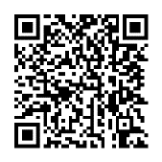
Stress, It’s Your Superpower | 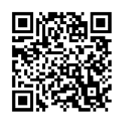 | Cultivating Positivity
Better Team Health Through Difficult Conversations |  | The Lost Art of Sleep | 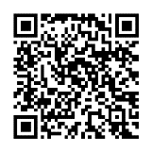

Your physical and emotional wellness is important to Organization Name. We hope you take advantage of these wellness resources. If you have any questions, please contact Risk Manager, Name, at email address or phone number OR Human Resources Director, Name at email address or phone number.

